**The Tragedy of Flight : A Comprehensive Crash Analysis**

1. **Introduction :-**

**1.1. Overview :-**

According to the nature of the accident (takeoff accidents, tail spins following engine failure, etc.), the degree of seriousness of. personnel injuries, and the amount of damage occurring to materiel

Furthermore, the system, through the use of a cross analysis method, allows for analyzing pilot errors and materiel failures according to the underlying causes of these errors or failures.

The plan also provides the aircraft accidents of different organizations on the same basis, so that the records will be comparable and the preparation of a composite report of all. Aircraft accidents will be possible. If all aircraft accidents occurring in all agencies are classified in the manner recommended a composite of all the accidents will offer a basis upon which a study may be made and correct conclusions drawn.

* 1. **Purpose :-**

We derive this analysis to know about the fact which causes the aircraft crashes and how to reduce them.

This analysis gives the ideas of protecting the planes from aircraft accident .

Also this analysis shows the death level information during this type of accident

1. **Problem Definitions And Designs Thinking :-**

**Empathy Map :-**

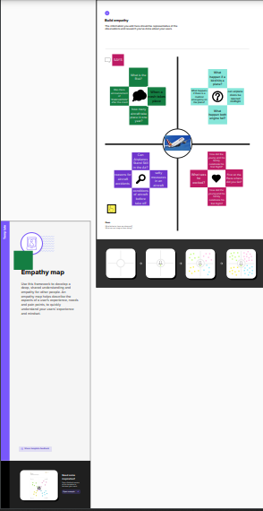

1. **Results :-**

**Tableau Output**

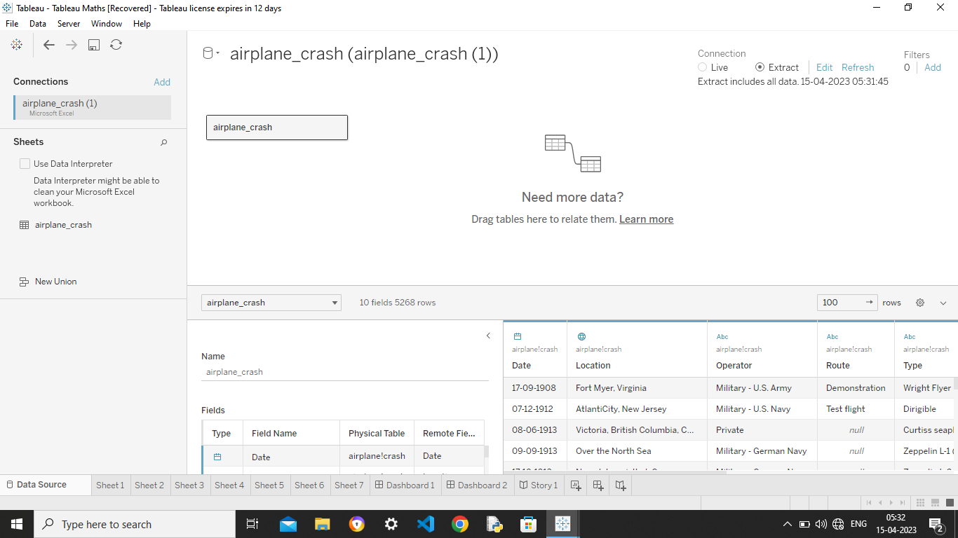

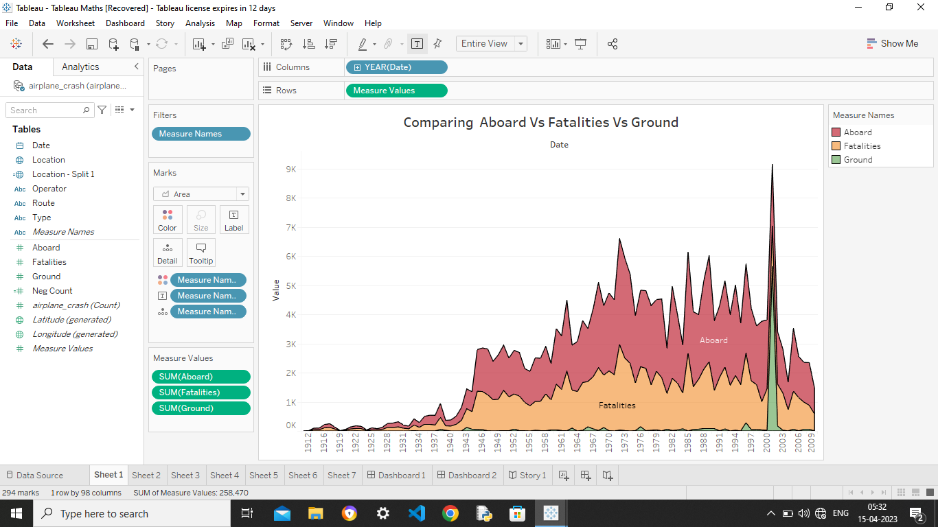

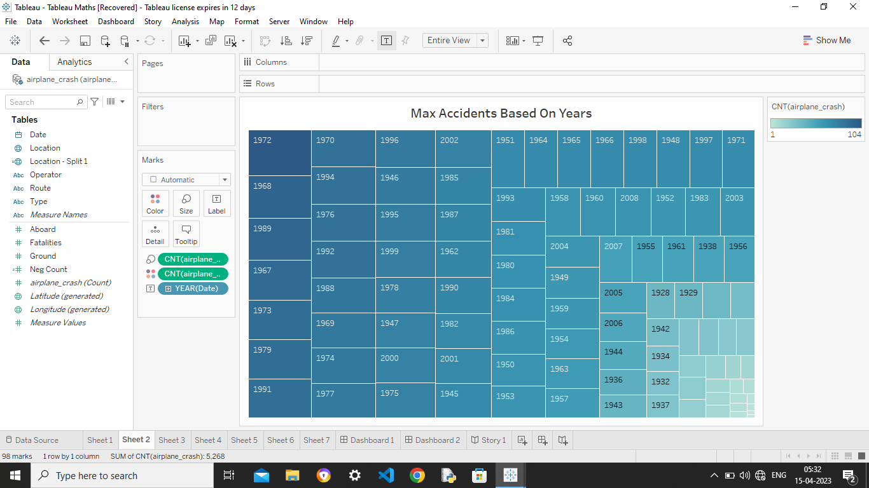

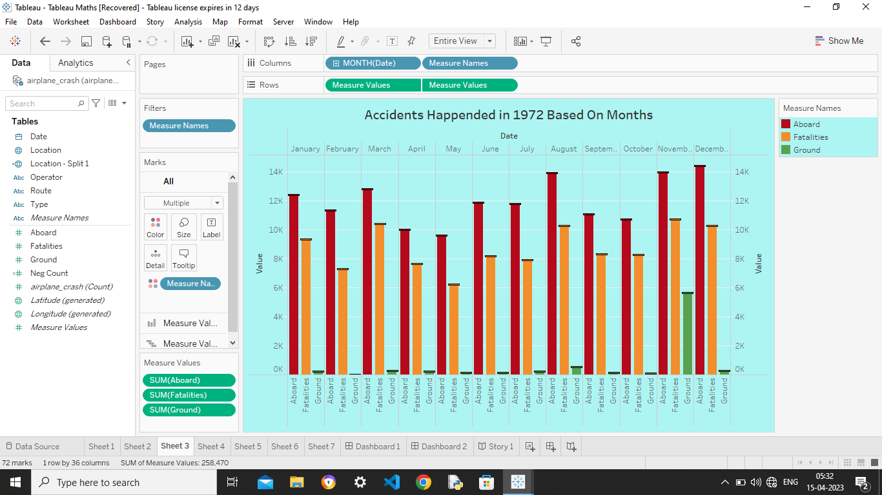

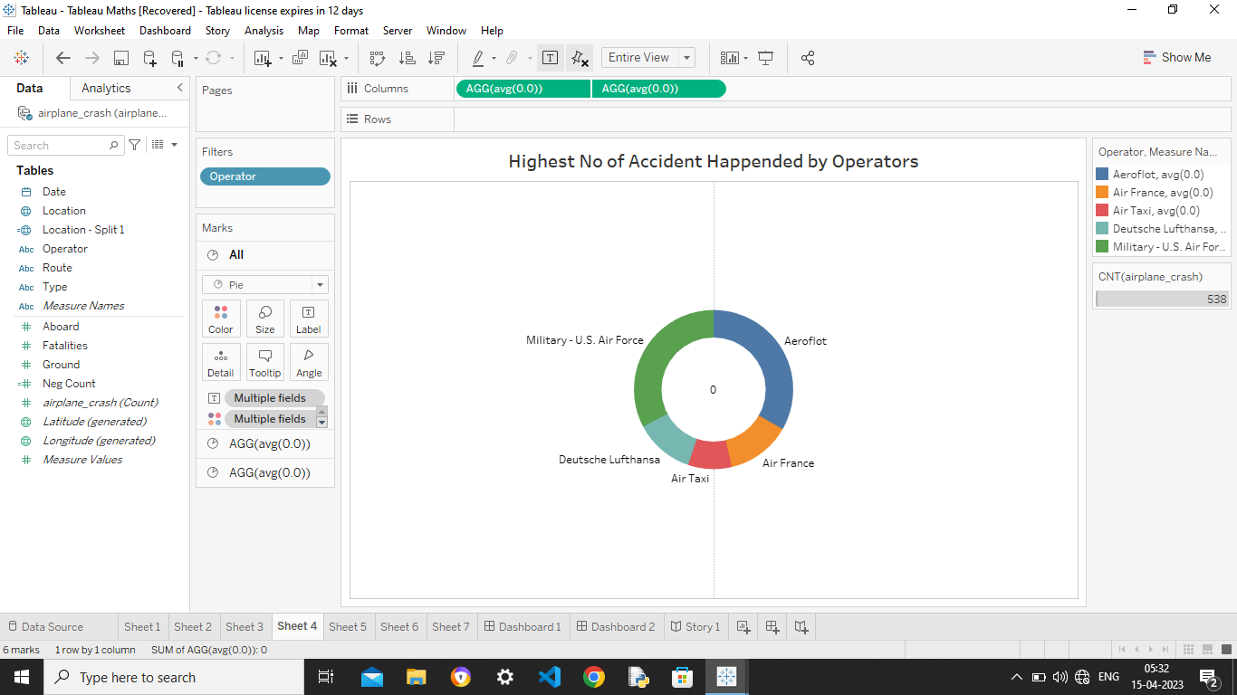

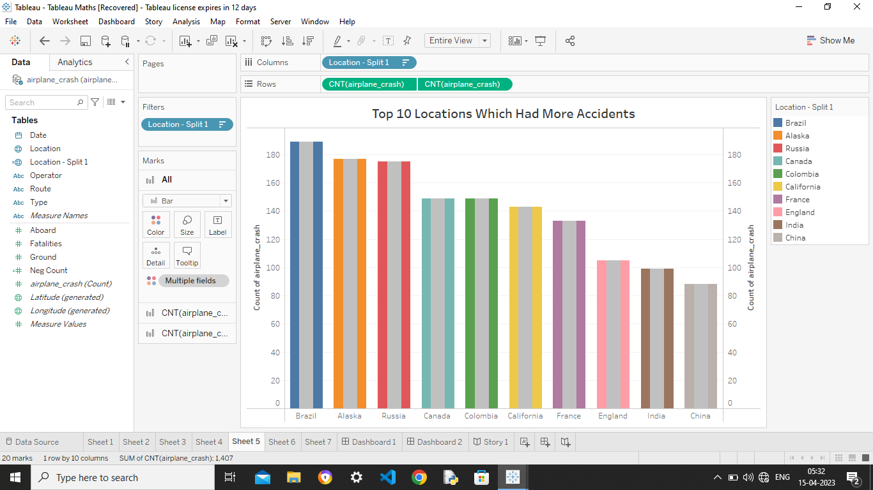

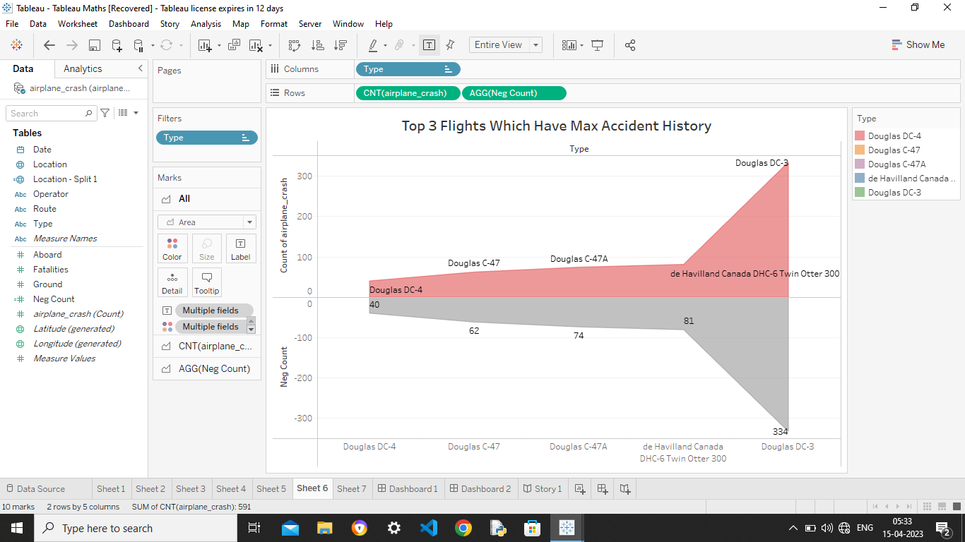

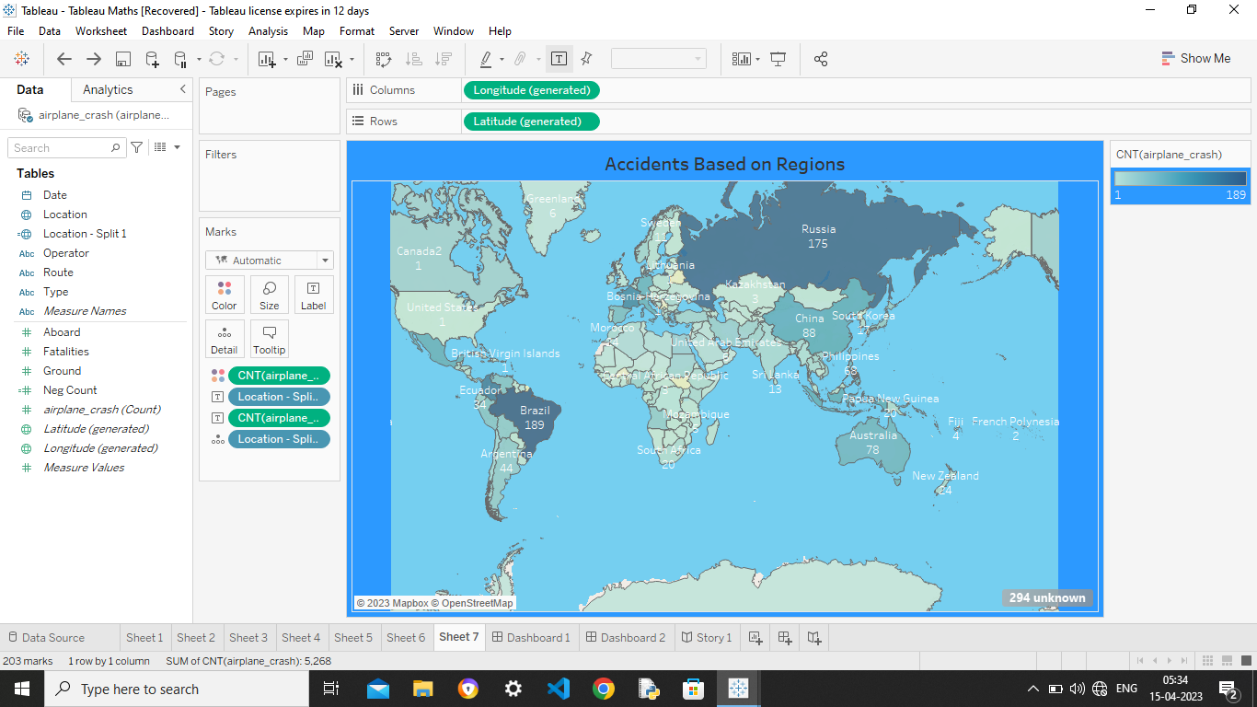

1. **Advantages and Disadvantages :-**

**4.1 : advantages of Aircraft Crash Analysis :-**

**Regulatory background**  
  
The development of requirements for safety assessment, FAR / EASA CS25—1309.  
  
**Methods and techniques**  
  
Introduction to the more common safety analysis techniques. Influence of human factors.  Common mode failures, traps and pitfalls of using safety assessment and examples of mechanical systems and power plants.  
  
**Use of safety assessment techniques**  
  
Determination of correct architecture of safety critical systems.  Fault Tree Analysis, Dependence Diagrams and Boolean algebra for quantification of system reliability.  Zonal safety analysis (ZSA), Particular Risk Analysis (PRA) and Failure Mode and Effect Analysis (FMEA) of aircraft systems.  
  
**Practical examples of the application of safety assessment techniques**  
  
Minimum Equipment Lists (MEL), Safety and Certification of digital systems and safety critical software.  Application of Aerospace Recommended Practice (ARP) 4761.  Typical safety assessment for a stall warning and identification system.  
 **Current and future issues**  
  
Integrated and modular systems and their certification.  Certification maintenance requirements.  Flight-deck ergonomics.

## 

## 4.2 : Disadvantages of Aircraft Crash Analysis:-

ir Transport carries certain disadvantages too and they are:

(i) Cost of operating airlines is very high and so freight cost is very high as compared to sea transport.

(ii) It is difficult to carry bulky, awkwardly shaped goods.

(iii) Very risky in case of accident.

(iv) It is controlled by climatic conditions; thus bad weather leads to uncertainty in its time table.

1. **Application :-**

Generally , According to the EU Council Directive 94/56/EC “The extent of investigations and the procedure to be followed in carrying out such investigations shall be determined by the investigating body, taking into account the principles and the objective of this Directive and depending on the lessons it expects to draw from the accident or serious incident for the improvement of safety”.

The extent of an investigation should depend on the actual or potential consequence or hazard. Incidents that indicate high risk potential should be investigated in greater depth than those with lower risk potential.

Although the investigation should primarily focus on the factors that are most likely to have influenced action, the dividing line between relevance and irrelevance is often blurred. Data that initially may seem to be unrelated could later prove to be relevant once the relationship between the different elements of an occurrence are better understood.

Investigation and analysis of safety occurrences is an essential ingredient of the overall [risk management](https://www.skybrary.aero/index.php/Risk_Management) process in aviation. Effective [safety management systems](https://www.skybrary.aero/index.php/Safety_Management_System) largely depend on the quality of the investigation of reported accidents, incidents and safety issues.

1. **Conclusion :-**

After during the project, we have realized the challenges faced with aircraft Crash Analysis and more about the safety management systems.

Hence we conclude the Aircraft crash Analysis.

**6.1 Dashboard :-**

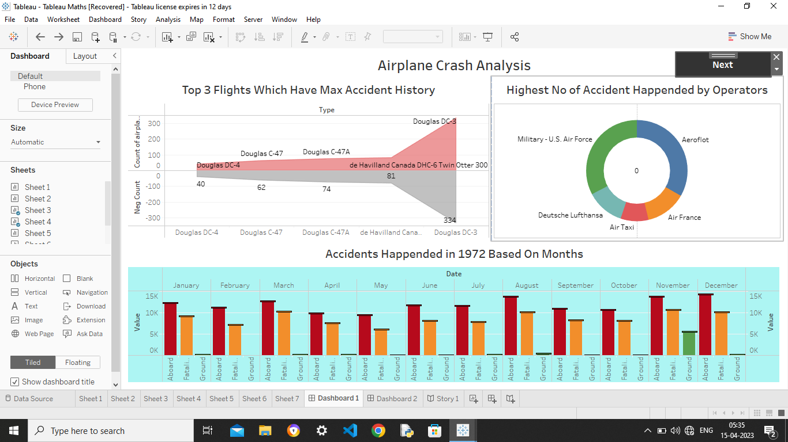

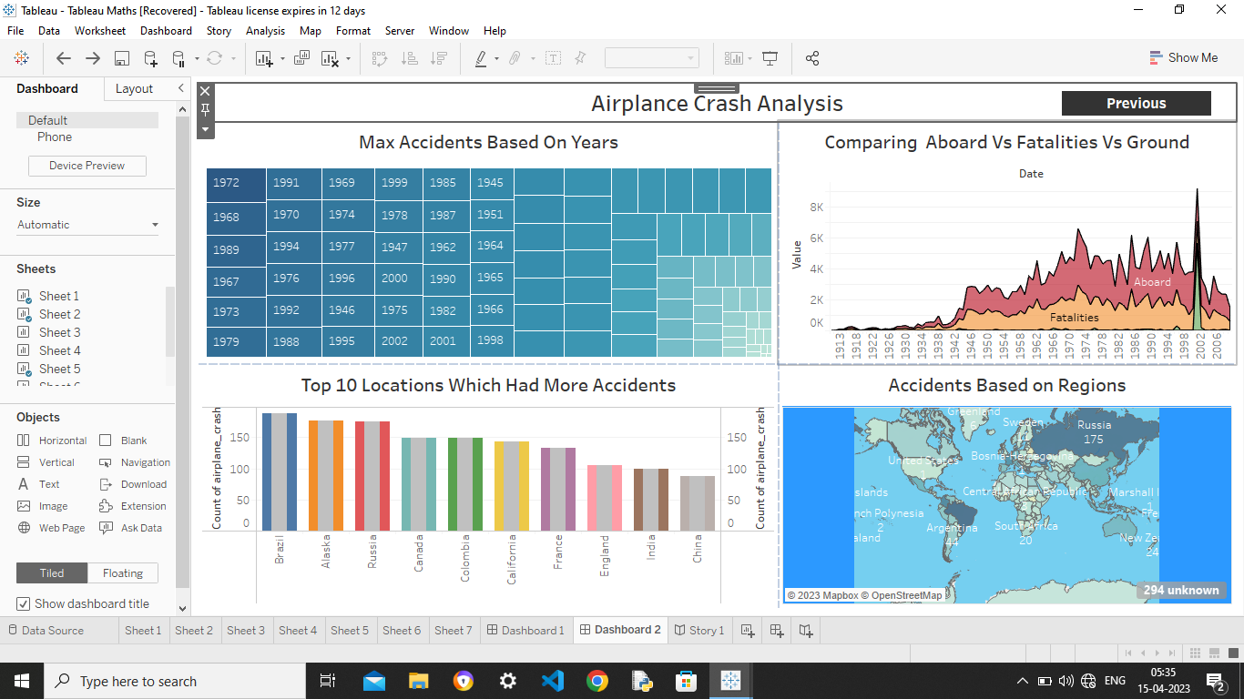

**6.2 Story :-**

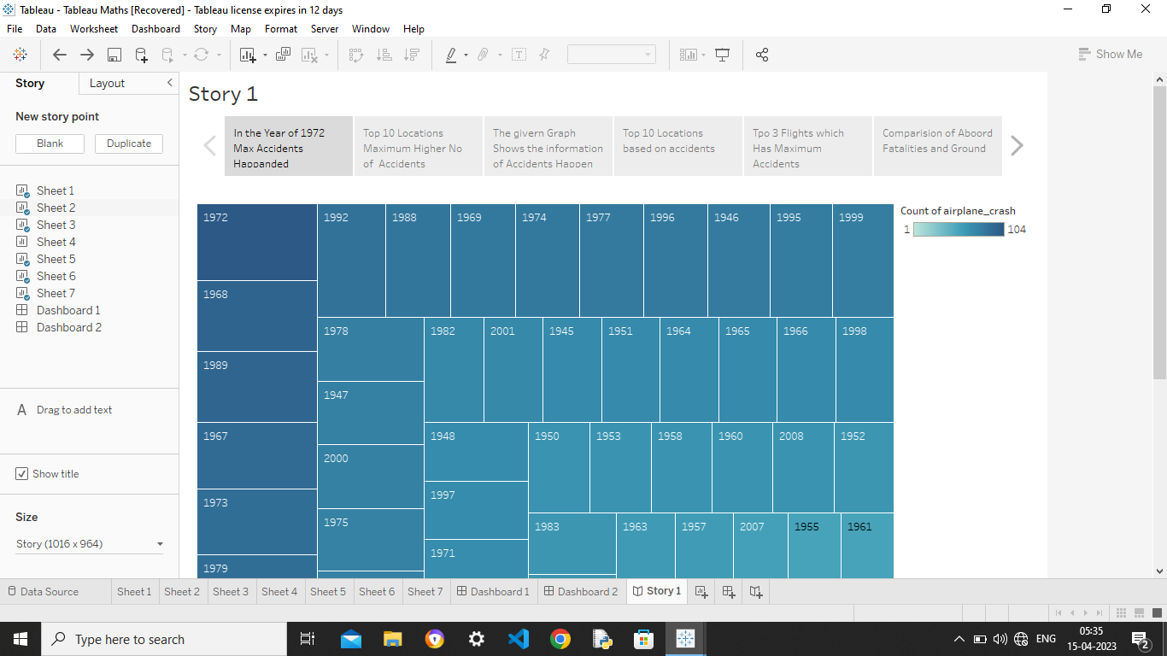

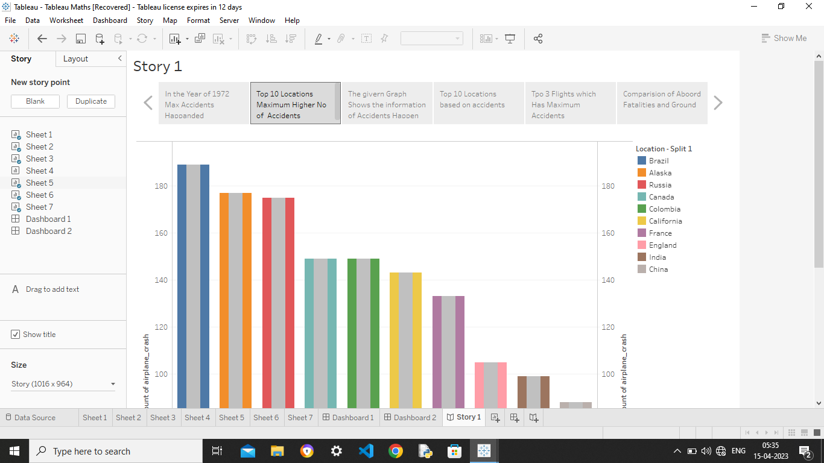



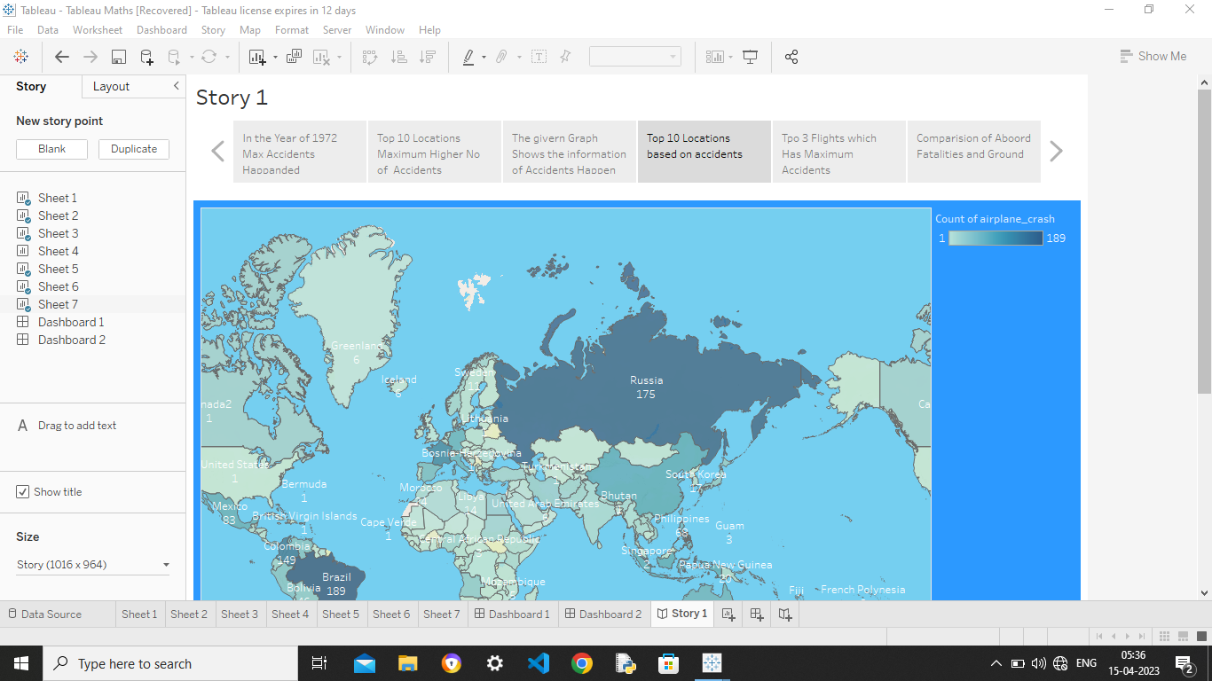

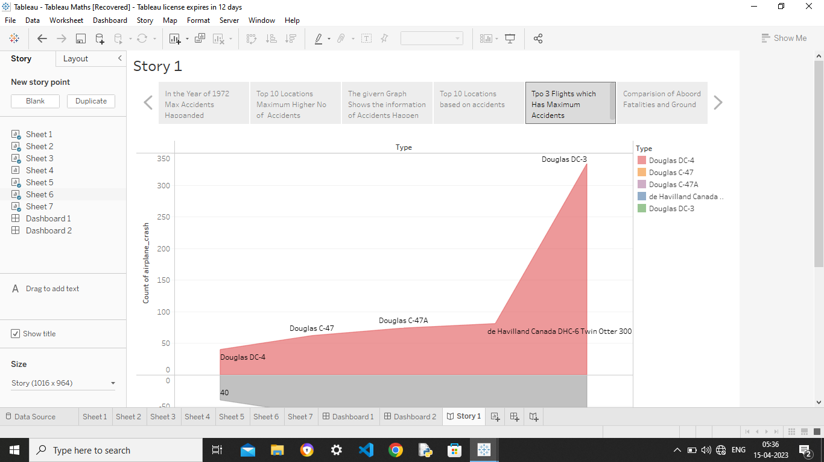

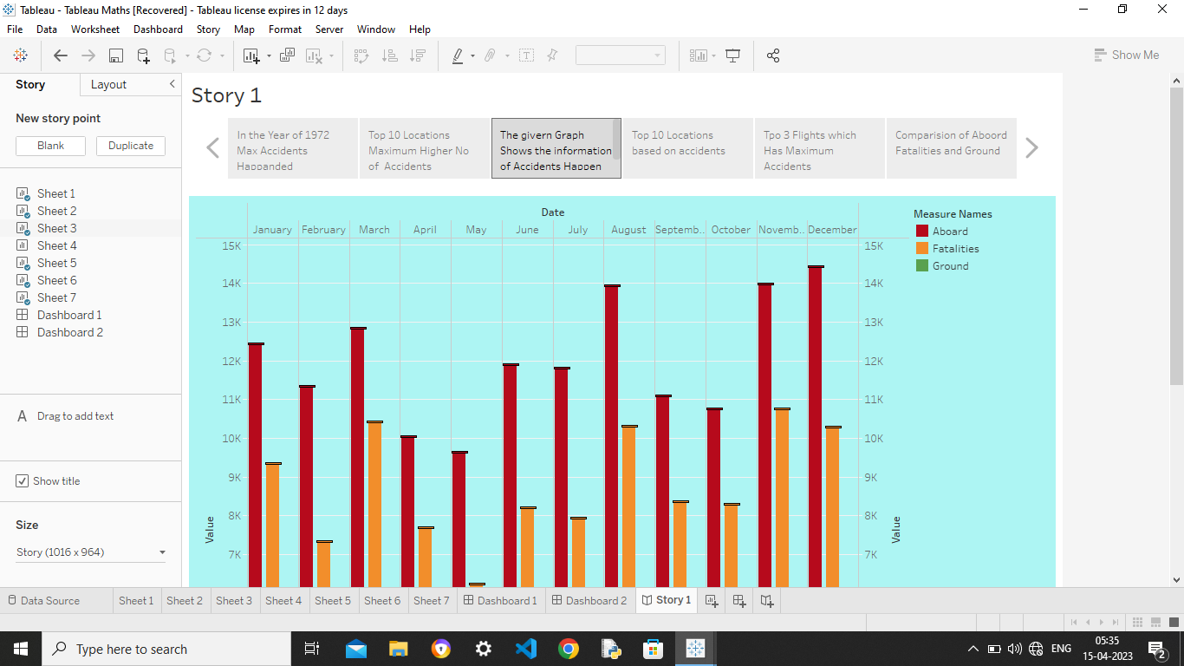

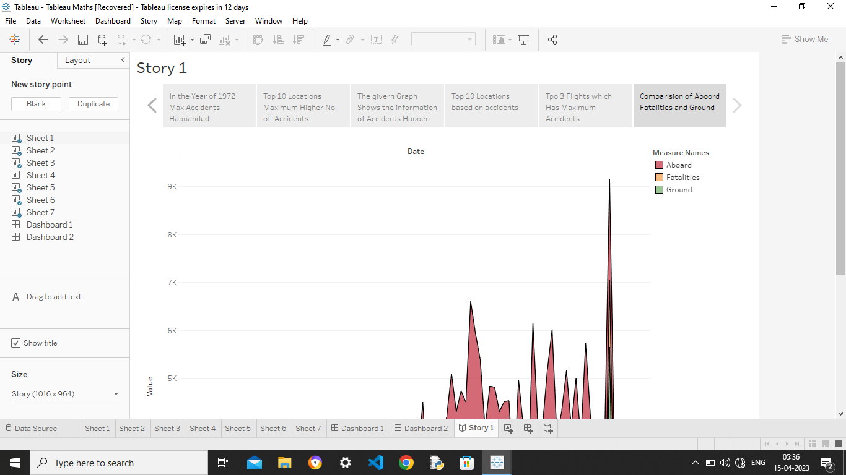

1. **Appendix :-**
   1. **Source Code :-**

**<!DOCTYPE html>**

**<html lang="en">**

**<head>**

**<meta charset="utf-8">**

**<meta content="width=device-width, initial-scale=1.0" name="viewport">**

**<title>SHPVIBE - Airplane Crash</title>**

**<meta content="" name="description">**

**<meta content="" name="keywords">**

**<!-- Favicons -->**

**<link href="assets/img/favicon.png" rel="icon">**

**<link href="assets/img/apple-touch-icon.png" rel="apple-touch-icon">**

**<!-- Google Fonts -->**

**<link href="https://fonts.googleapis.com/css?family=Open+Sans:300,300i,400,400i,600,600i,700,700i|Jost:300,300i,400,400i,500,500i,600,600i,700,700i|Poppins:300,300i,400,400i,500,500i,600,600i,700,700i" rel="stylesheet">**

**<!-- Vendor CSS Files -->**

**<link href="assets/vendor/aos/aos.css" rel="stylesheet">**

**<link href="assets/vendor/bootstrap/css/bootstrap.min.css" rel="stylesheet">**

**<link href="assets/vendor/bootstrap-icons/bootstrap-icons.css" rel="stylesheet">**

**<link href="assets/vendor/boxicons/css/boxicons.min.css" rel="stylesheet">**

**<link href="assets/vendor/glightbox/css/glightbox.min.css" rel="stylesheet">**

**<link href="assets/vendor/remixicon/remixicon.css" rel="stylesheet">**

**<link href="assets/vendor/swiper/swiper-bundle.min.css" rel="stylesheet">**

**<!-- Template Main CSS File -->**

**<link href="assets/css/style.css" rel="stylesheet">**

**<!-- =======================================================**

**\* Template Name: Arsha - v4.9.1**

**\* Template URL: https://bootstrapmade.com/arsha-free-bootstrap-html-template-corporate/**

**\* Author: BootstrapMade.com**

**\* License: https://bootstrapmade.com/license/**

**======================================================== -->**

**</head>**

**<body>**

**<!-- ======= Header ======= -->**

**<header id="header" class="fixed-top ">**

**<div class="container d-flex align-items-center">**

**<h1 class="logo me-auto"><a href="index.html">SHPVIBE</a></h1>**

**<!-- Uncomment below if you prefer to use an image logo -->**

**<!-- <a href="index.html" class="logo me-auto"><img src="assets/img/logo.png" alt="" class="img-fluid"></a>-->**

**<nav id="navbar" class="navbar">**

**<ul>**

**<li><a class="nav-link scrollto active" href="#hero">Home</a></li>**

**<li><a class="nav-link scrollto" href="#about">About</a></li>**

**<li><a class="nav-link scrollto" href="#team">Dashboard</a></li>**

**<li><a class="nav-link scrollto" href="#pricing">Story</a></li>**

**<li><a class="nav-link scrollto" href="#contact">Contact</a></li>**

**<li><a class="getstarted scrollto" href="#about">Get Started</a></li>**

**</ul>**

**<i class="bi bi-list mobile-nav-toggle"></i>**

**</nav><!-- .navbar -->**

**</div>**

**</header><!-- End Header -->**

**<!-- ======= Hero Section ======= -->**

**<section id="hero" class="d-flex align-items-center">**

**<div class="container">**

**<div class="row">**

**<div class="col-lg-6 d-flex flex-column justify-content-center pt-4 pt-lg-0 order-2 order-lg-1" data-aos="fade-up" data-aos-delay="200">**

**<h1>Airplane Crash analysis</h1>**

**<h2>Airplane Crashes and Fatalities Since 1908</h2>**

**<div class="d-flex justify-content-center justify-content-lg-start">**

**<a href="#about" class="btn-get-started scrollto">Get Started</a>**

**<a href="https://www.youtube.com/@thesmartbridge/videos" class="glightbox btn-watch-video"><i class="bi bi-play-circle"></i><span>Watch Video</span></a>**

**</div>**

**</div>**

**<div class="col-lg-6 order-1 order-lg-2 hero-img" data-aos="zoom-in" data-aos-delay="200">**

**<img src="assets/img/a1.jpg" class="img-fluid animated" alt="">**

**</div>**

**</div>**

**</div>**

**</section><!-- End Hero -->**

**<main id="main">**

**<!-- ======= About Us Section ======= -->**

**<section id="about" class="about">**

**<div class="container" data-aos="fade-up">**

**<div class="section-title">**

**<h2>About Project</h2>**

**</div>**

**<div class="row content">**

**<div class="col-lg-6">**

**<p>**

**An aviation accident is defined by the Convention on International Civil Aviation Annex 13 as an occurrence associated with the operation of an aircraft, which takes place from the time any person boards the aircraft with the intention of flight until all such persons have disembarked, and in which**

**</p>**

**<ul>**

**<li><i class="ri-check-double-line"></i> a) a person is fatally or seriously injured, </li>**

**<li><i class="ri-check-double-line"></i> b) the aircraft sustains significant damage or structural failure, or </li>**

**<li><i class="ri-check-double-line"></i> c) the aircraft goes missing or becomes completely inaccessible.</li>**

**</ul>**

**</div>**

**<div class="col-lg-6 pt-4 pt-lg-0">**

**<p>**

**This dataset includes:**

**<ul>**

**<li><i class="ri-check-double-line"></i> All civil and commercial aviation accidents of scheduled and non-scheduled passenger airliners worldwide, which resulted in a fatality (including all U.S. Part 121 and Part 135 fatal accidents)</li>**

**<li><i class="ri-check-double-line"></i> All cargo, positioning, ferry and test flight fatal accidents.</li>**

**<li><i class="ri-check-double-line"></i> All military transport accidents with 10 or more fatalities.</li>**

**<li><i class="ri-check-double-line"></i> All commercial and military helicopter accidents with greater than 10 fatalities.</li>**

**<li><i class="ri-check-double-line"></i> All civil and military airship accidents involving fatalities.</li>**

**<li><i class="ri-check-double-line"></i> Aviation accidents involving the death of famous people.</li>**

**</ul>**

**</p>**

**</div>**

**</div>**

**</div>**

**</section><!-- End About Us Section -->**

**<!-- ======= Cta Section ======= -->**

**<section id="cta" class="cta">**

**<div class="container" data-aos="zoom-in">**

**<div class="row">**

**<div class="col-lg-9 text-center text-lg-start">**

**<h3>Call To Action</h3>**

**</div>**

**<div class="col-lg-3 cta-btn-container text-center">**

**<a class="cta-btn align-middle" href="#">Call To Action</a>**

**</div>**

**</div>**

**</div>**

**</section><!-- End Cta Section -->**

**<!-- ======= Team Section ======= -->**

**<section id="team" class="team section-bg">**

**<div class="container" data-aos="fade-up">**

**<div class="section-title">**

**<h2>Dashboard</h2>**

**</div>**

**<div class='tableauPlaceholder' id='viz1671640028467' style='position: relative'><noscript><a href='#'><img alt='Airplane Crash Analysis ' src='https:&#47;&#47;public.tableau.com&#47;static&#47;images&#47;Ai&#47;Airplane_Crash&#47;Dashboard1&#47;1_rss.png' style='border: none' /></a></noscript><object class='tableauViz' style='display:none;'><param name='host_url' value='https%3A%2F%2Fpublic.tableau.com%2F' /> <param name='embed_code_version' value='3' /> <param name='site_root' value='' /><param name='name' value='Airplane_Crash&#47;Dashboard1' /><param name='tabs' value='no' /><param name='toolbar' value='yes' /><param name='static_image' value='https:&#47;&#47;public.tableau.com&#47;static&#47;images&#47;Ai&#47;Airplane_Crash&#47;Dashboard1&#47;1.png' /> <param name='animate_transition' value='yes' /><param name='display_static_image' value='yes' /><param name='display_spinner' value='yes' /><param name='display_overlay' value='yes' /><param name='display_count' value='yes' /><param name='language' value='en-US' /><param name='filter' value='publish=yes' /></object></div> <script type='text/javascript'> var divElement = document.getElementById('viz1671640028467'); var vizElement = divElement.getElementsByTagName('object')[0]; if ( divElement.offsetWidth > 800 ) { vizElement.style.width='100%';vizElement.style.height=(divElement.offsetWidth*0.75)+'px';} else if ( divElement.offsetWidth > 500 ) { vizElement.style.width='100%';vizElement.style.height=(divElement.offsetWidth*0.75)+'px';} else { vizElement.style.width='100%';vizElement.style.height='1027px';} var scriptElement = document.createElement('script'); scriptElement.src = 'https://public.tableau.com/javascripts/api/viz_v1.js'; vizElement.parentNode.insertBefore(scriptElement, vizElement); </script>**

**</div><div class='tableauPlaceholder' id='viz1681566769804' style='position: relative'><noscript><a href='#'><img alt='Airplane Crash Analysis ' src='https:&#47;&#47;public.tableau.com&#47;static&#47;images&#47;Ta&#47;TableauMaths&#47;Dashboard1&#47;1_rss.png' style='border: none' /></a></noscript><object class='tableauViz' style='display:none;'><param name='host_url' value='https%3A%2F%2Fpublic.tableau.com%2F' /> <param name='embed_code_version' value='3' /> <param name='site_root' value='' /><param name='name' value='TableauMaths&#47;Dashboard1' /><param name='tabs' value='no' /><param name='toolbar' value='yes' /><param name='static_image' value='https:&#47;&#47;public.tableau.com&#47;static&#47;images&#47;Ta&#47;TableauMaths&#47;Dashboard1&#47;1.png' /> <param name='animate_transition' value='yes' /><param name='display_static_image' value='yes' /><param name='display_spinner' value='yes' /><param name='display_overlay' value='yes' /><param name='display_count' value='yes' /><param name='language' value='en-US' /></object></div> <script type='text/javascript'> var divElement = document.getElementById('viz1681566769804'); var vizElement = divElement.getElementsByTagName('object')[0]; if ( divElement.offsetWidth > 800 ) { vizElement.style.width='100%';vizElement.style.height=(divElement.offsetWidth*0.75)+'px';} else if ( divElement.offsetWidth > 500 ) { vizElement.style.width='100%';vizElement.style.height=(divElement.offsetWidth*0.75)+'px';} else { vizElement.style.width='100%';vizElement.style.height='1027px';} var scriptElement = document.createElement('script'); scriptElement.src = 'https://public.tableau.com/javascripts/api/viz_v1.js'; vizElement.parentNode.insertBefore(scriptElement, vizElement); </script>**

**</section><!-- End Team Section -->**

**<!-- ======= Pricing Section ======= -->**

**<section id="pricing" class="pricing">**

**<div class="container" data-aos="fade-up">**

**<div class="section-title">**

**<h2>Story</h2>**

**</div><div class='tableauPlaceholder' id='viz1681568411274' style='position: relative'><noscript><a href='#'><img alt='Story 1 ' src='https:&#47;&#47;public.tableau.com&#47;static&#47;images&#47;Ta&#47;TableauMaths1&#47;Story1&#47;1_rss.png' style='border: none' /></a></noscript><object class='tableauViz' style='display:none;'><param name='host_url' value='https%3A%2F%2Fpublic.tableau.com%2F' /> <param name='embed_code_version' value='3' /> <param name='site_root' value='' /><param name='name' value='TableauMaths1&#47;Story1' /><param name='tabs' value='no' /><param name='toolbar' value='yes' /><param name='static_image' value='https:&#47;&#47;public.tableau.com&#47;static&#47;images&#47;Ta&#47;TableauMaths1&#47;Story1&#47;1.png' /> <param name='animate_transition' value='yes' /><param name='display_static_image' value='yes' /><param name='display_spinner' value='yes' /><param name='display_overlay' value='yes' /><param name='display_count' value='yes' /><param name='language' value='en-US' /></object></div> <script type='text/javascript'> var divElement = document.getElementById('viz1681568411274'); var vizElement = divElement.getElementsByTagName('object')[0]; vizElement.style.width='1016px';vizElement.style.height='991px'; var scriptElement = document.createElement('script'); scriptElement.src = 'https://public.tableau.com/javascripts/api/viz_v1.js'; vizElement.parentNode.insertBefore(scriptElement, vizElement); </script>**

**<div class='tableauPlaceholder' id='viz1671640137789' style='position: relative'><noscript><a href='#'><img alt='Story 1 ' src='https:&#47;&#47;public.tableau.com&#47;static&#47;images&#47;Ai&#47;Airplane_Crash_story&#47;Story1&#47;1_rss.png' style='border: none' /></a></noscript><object class='tableauViz' style='display:none;'><param name='host_url' value='https%3A%2F%2Fpublic.tableau.com%2F' /> <param name='embed_code_version' value='3' /> <param name='site_root' value='' /><param name='name' value='Airplane_Crash_story&#47;Story1' /><param name='tabs' value='no' /><param name='toolbar' value='yes' /><param name='static_image' value='https:&#47;&#47;public.tableau.com&#47;static&#47;images&#47;Ai&#47;Airplane_Crash_story&#47;Story1&#47;1.png' /> <param name='animate_transition' value='yes' /><param name='display_static_image' value='yes' /><param name='display_spinner' value='yes' /><param name='display_overlay' value='yes' /><param name='display_count' value='yes' /><param name='language' value='en-US' /><param name='filter' value='publish=yes' /></object></div> <script type='text/javascript'> var divElement = document.getElementById('viz1671640137789'); var vizElement = divElement.getElementsByTagName('object')[0]; vizElement.style.width='100%';vizElement.style.height=(divElement.offsetWidth*0.75)+'px'; var scriptElement = document.createElement('script'); scriptElement.src = 'https://public.tableau.com/javascripts/api/viz_v1.js'; vizElement.parentNode.insertBefore(scriptElement, vizElement); </script>**

**</div>**

**</section><!-- End Pricing Section -->**

**<!-- ======= Contact Section ======= -->**

**<section id="contact" class="contact">**

**<div class="container" data-aos="fade-up">**

**<div class="section-title">**

**<h2>Contact</h2>**

**</div>**

**<div class="row">**

**<div class="col-lg-5 d-flex align-items-stretch">**

**<div class="info">**

**<div class="address">**

**<i class="bi bi-geo-alt"></i>**

**<h4>Location:</h4>**

**<p>xxxxxx Street, xxx, xx 53xxx2</p>**

**</div>**

**<div class="email">**

**<i class="bi bi-envelope"></i>**

**<h4>Email:</h4>**

**<p>info@example.com</p>**

**</div>**

**<div class="phone">**

**<i class="bi bi-phone"></i>**

**<h4>Call:</h4>**

**<p>+1 5xxx 5xxx8 5xs</p>**

**</div>**

**<iframe src="https://www.google.com/maps/embed?pb=!1m14!1m8!1m3!1d12097.433213460943!2d-74.0062269!3d40.7101282!3m2!1i1024!2i768!4f13.1!3m3!1m2!1s0x0%3A0xb89d1fe6bc499443!2sDowntown+Conference+Center!5e0!3m2!1smk!2sbg!4v1539943755621" frameborder="0" style="border:0; width: 100%; height: 290px;" allowfullscreen></iframe>**

**</div>**

**</div>**

**<div class="col-lg-7 mt-5 mt-lg-0 d-flex align-items-stretch">**

**<form action="forms/contact.php" method="post" role="form" class="php-email-form">**

**<div class="row">**

**<div class="form-group col-md-6">**

**<label for="name">Your Name</label>**

**<input type="text" name="name" class="form-control" id="name" required>**

**</div>**

**<div class="form-group col-md-6">**

**<label for="name">Your Email</label>**

**<input type="email" class="form-control" name="email" id="email" required>**

**</div>**

**</div>**

**<div class="form-group">**

**<label for="name">Subject</label>**

**<input type="text" class="form-control" name="subject" id="subject" required>**

**</div>**

**<div class="form-group">**

**<label for="name">Message</label>**

**<textarea class="form-control" name="message" rows="10" required></textarea>**

**</div>**

**<div class="my-3">**

**<div class="loading">Loading</div>**

**<div class="error-message"></div>**

**<div class="sent-message">Your message has been sent. Thank you!</div>**

**</div>**

**<div class="text-center"><button type="submit">Send Message</button></div>**

**</form>**

**</div>**

**</div>**

**</div>**

**</section><!-- End Contact Section -->**

**</main><!-- End #main -->**

**<!-- ======= Footer ======= -->**

**<footer id="footer">**

**<div class="footer-newsletter">**

**<div class="container">**

**<div class="row justify-content-center">**

**<div class="col-lg-6">**

**<h4>Join Our Newsletter</h4>**

**<form action="" method="post">**

**<input type="email" name="email"><input type="submit" value="Subscribe">**

**</form>**

**</div>**

**</div>**

**</div>**

**</div>**

**<div class="footer-top">**

**<div class="container">**

**<div class="row">**

**<div class="col-lg-3 col-md-6 footer-links">**

**<h4>Useful Links</h4>**

**<ul>**

**<li><i class="bx bx-chevron-right"></i> <a href="#hero">Home</a></li>**

**<li><i class="bx bx-chevron-right"></i> <a href="#about">About</a></li>**

**<li><i class="bx bx-chevron-right"></i> <a href="#portfolio">Charts</a></li>**

**<li><i class="bx bx-chevron-right"></i> <a href="#team">Dashboard</a></li>**

**<li><i class="bx bx-chevron-right"></i> <a href="#pricing">Story</a></li>**

**</ul>**

**</div>**

**<div class="col-lg-3 col-md-6 footer-links">**

**<h4></h4>**

**<ul>**

**</ul>**

**</div>**

**<div class="col-lg-3 col-md-6 footer-links">**

**<h4></h4>**

**<ul>**

**</ul>**

**</div>**

**<div class="col-lg-3 col-md-6 footer-links">**

**<h4>Our Social Networks</h4>**

**<div class="social-links mt-3">**

**<a href="https://www.linkedin.com/in/hariprabu741/" class="linkedin"><i class="bx bxl-linkedin"></i></a>**

**<a href="#" class="twitter"><i class="bx bxl-twitter"></i></a>**

**<a href="#" class="facebook"><i class="bx bxl-facebook"></i></a>**

**<a href="#" class="instagram"><i class="bx bxl-instagram"></i></a>**

**<a href="#" class="google-plus"><i class="bx bxl-skype"></i></a>**

**</div>**

**</div>**

**</div>**

**</div>**

**</div>**

**<div class="container footer-bottom clearfix">**

**<div class="copyright">**

**&copy; Copyright <strong><span>SHPVIBE</span></strong>. All Rights Reserved**

**</div>**

**<div class="credits">**

**<!-- All the links in the footer should remain intact. -->**

**<!-- You can delete the links only if you purchased the pro version. -->**

**<!-- Licensing information: https://bootstrapmade.com/license/ -->**

**<!-- Purchase the pro version with working PHP/AJAX contact form: https://bootstrapmade.com/arsha-free-bootstrap-html-template-corporate/ -->**

**Designed by <a href="https://bootstrapmade.com/">SHPVIBE</a>**

**</div>**

**</div>**

**</footer><!-- End Footer -->**

**<div id="preloader"></div>**

<a href="#" class="back-to-top d-flex align-items-center justify-content-center"><i class="bi bi-arrow-up-short"></i></a>

<!-- Vendor JS Files -->

<script src="assets/vendor/aos/aos.js"></script>

<script src="assets/vendor/bootstrap/js/bootstrap.bundle.min.js"></script>

<script src="assets/vendor/glightbox/js/glightbox.min.js"></script>

<script src="assets/vendor/isotope-layout/isotope.pkgd.min.js"></script>

<script src="assets/vendor/swiper/swiper-bundle.min.js"></script>

<script src="assets/vendor/waypoints/noframework.waypoints.js"></script>

<script src="assets/vendor/php-email-form/validate.js"></script>

<!-- Template Main JS File -->

<script src="assets/js/main.js"></script>

</body>

</html>